🔁 Concept – Transistor me current aur MOSFET me voltage control
Haan, bilkul sahi samjhe ho:
- BJT (Transistor) = current controlled device
- MOSFET = voltage controlled device

Short Definition
Device | Control ka type
BJT | Base par current doge tab ON hoga
MOSFET | Gate par voltage doge tab ON hoga

Use Case with Example
🔹 BJT (NPN)
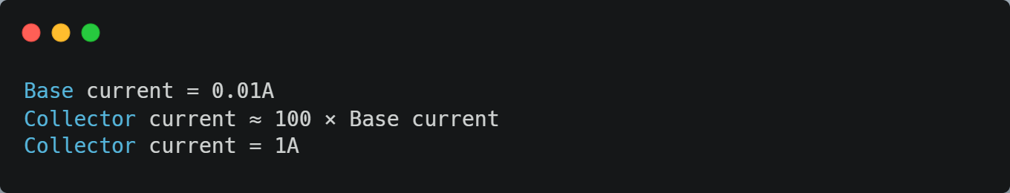
👉 Thoda sa current base par → bada current C-E me
🔹 MOSFET (N-Channel)
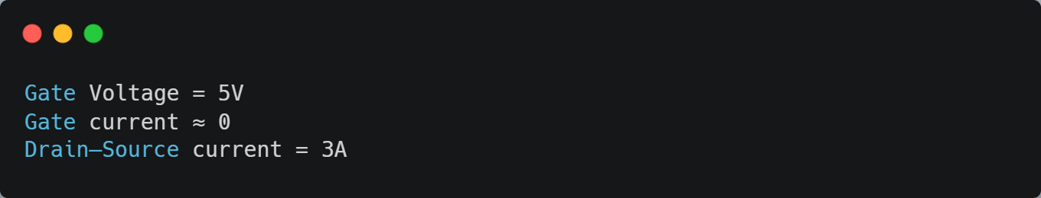
👉 Gate par sirf voltage, almost current nahi lagta
Flow Diagram
BJT
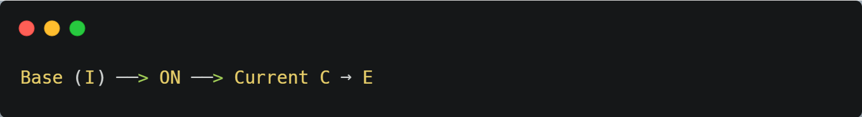
MOSFET
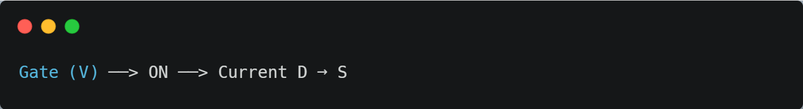

Note
- MOSFET voltage se ON hota hai, par Gate me continuous current flow nahi hota.
Short Definition
- Gate = capacitor jaisa hota hai
- Isliye gate par DC current ≈ 0 hota hai
- Sirf charging time par thoda sa current jata hai
MOSFET gate par voltage hota hai, par current sirf charging moment me aata hai – normal ON state me current ≈ 0.
Isliye MOSFET zyada efficient hota hai BJT se.
MOSFET ko ON rakhe rehne ke liye Gate par voltage continuously present rehna zaroori hai.
Gate voltage hatate hi MOSFET OFF ho jata hai.
- MOSFET tab tak ON rehta hai jab tak Gate-Source voltage (Vgs) present rehta hai.
🔌 Concept – Gate-Source Voltage (Vgs) kya hota hai?
Vgs = Gate aur Source ke beech ka voltage.
Ye hi voltage decide karta hai MOSFET ON hoga ya OFF.
Short Definition
Vgs=VGate−VSourceVgs
- Vgs ≥ Vth → MOSFET ON
- Vgs < Vth → MOSFET OFF
Use Case with Example
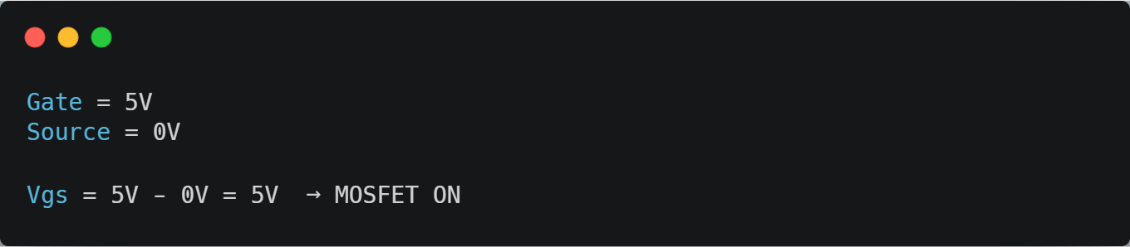
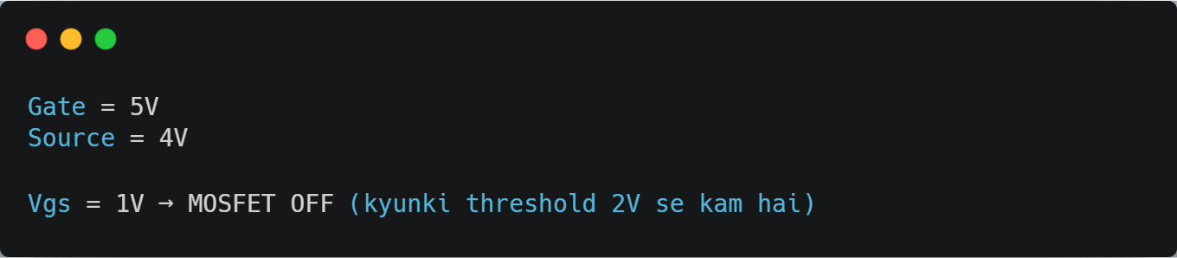
Diagram
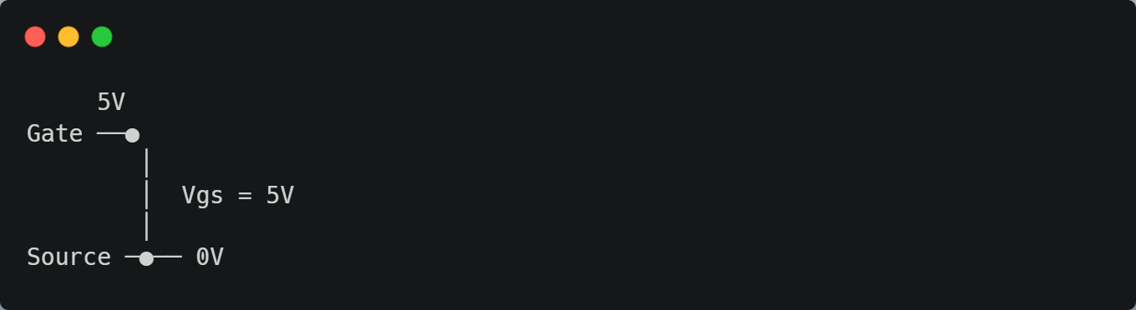

Final Line
MOSFET ko ON ya OFF karne ka asli control “Gate aur Source ke beech ka voltage (Vgs)” karta hai, na ki sirf gate ka voltage.

- 🔄 Concept – Vgs control N-Channel & P-Channel dono MOSFET me hota hai
Haan, N-Channel aur P-Channel – dono MOSFET ka ON/OFF sirf “Vgs” par depend karta hai.
Bas polarity ulti hoti hai.
Short Definition
Vgs=VGate−VSourceVgs
Type | ON condition
N-Channel | Vgs positive & Vgs ≥ Vth
P-Channel | Vgs negative & |Vgs| ≥ Vth

🔹 N-Channel
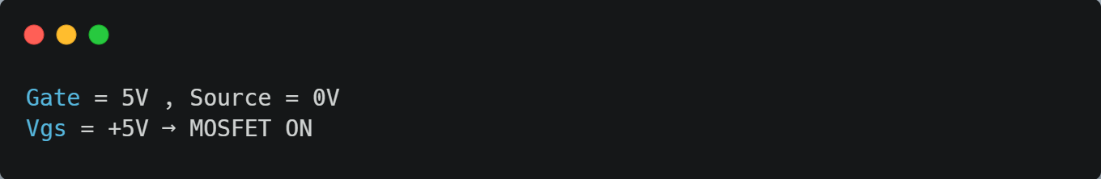
🔹 P-Channel
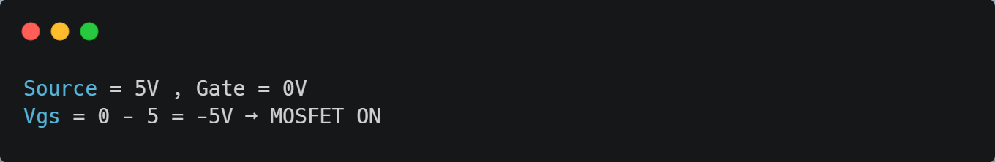

​ Real Life Example
- N-Channel = gate upar uthao → switch ON
- P-Channel = gate neeche lao → switch ON
✅ Final Line
Dono MOSFET me control “Vgs” hi karta hai –
N-Channel ko positive Vgs chahiye,
P-Channel ko negative Vgs.

